**Analyzing the transcript of Marilyn Mosby’s statement on Freddie Gray case**

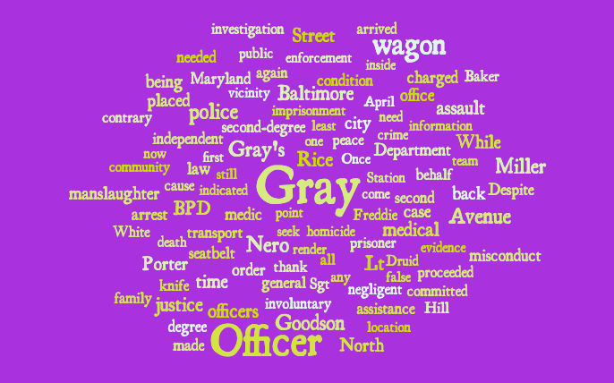

In the wake of Freddie Gray’s death while in police custody and the resulting civil unrest within the city of Baltimore, Marilyn Mosby stood outside the Baltimore City Circuit Court and issued a lengthy statement regarding the investigation into Gray’s death. Over the course of her statement to the press, she announced that the State’s Attorney’s Office would be declaring Gray’s death a homicide and that criminal charges were being filed against the five Baltimore City police officers involved in the incident.

Mosby called for justice to be pursued in Gray’s name and for the officers to receive punishment for their actions — actions she described throughout her statement with words like “assault,” “negligence,” and “misconduct.” A word analysis on the transcript of her statement indicates that Mosby reiterated sentiments including the word “justice” 11 times, while the word “assault” was mentioned 9 times. Mosby also made frequent appeals to the “community” and the “public,” seemingly framing Gray’s case as indicative of larger systemic corruption within the Baltimore City Police Department.